**Workshop 7 – Crash Course on Web Programming**

This is Part I of a series hands-on exercise getting you up to speed with Web programming. The topics to be covered include

* Basic HTML tagged structure
* Table for content organization
* Image (and other media)
* JavaScript for user interaction
* Using TTS
* Div’s for layout
* CSS basics

Many online tutorials provide introductions and sample code on these topics. Sections of HTML tutorials on w3schools.com are listed below to get you started (if needed).

HTML Tutorial | Home at <https://www.w3schools.com/html/default.asp>.

* First few sections (till Paragraph) are easy but essential. Please go over them if you have not tried them before.
* You can jump through the topics on Color, CSS, Links, Images, Tables, etc. when needed. We are using them in this workshop.
* 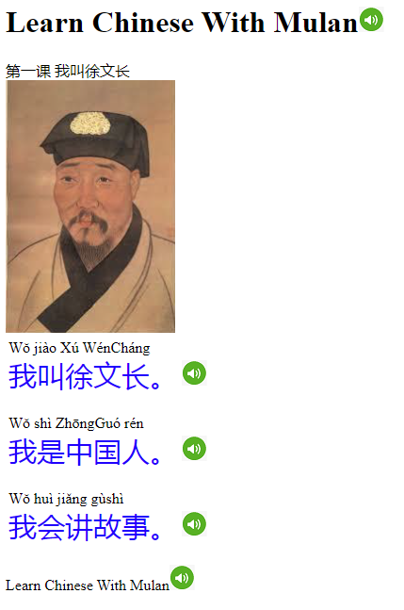CSS tutorial and JavaScript tutorial are right next. Look up for certain details when needed in these exercises.
  + JavaScript Objects and Functions will be used. They are very similar to Java.

Study the html file as provided.

1. Make sure you understand the basic structure, such as the HTML, HEAD, BODY, and elements like paragraph, table, used in the file.
2. The image files may be missing at this time. Find out what files are needed. Create a folder in your project folder and save the downloaded images there. Change the “src” attribute to the new value as appropriate, and make sure images shows well in your page.
3. Check to see how text to speech is done in the code. It involves JavaScript programming using the Web Speech API (<https://developer.mozilla.org/en-US/docs/Web/API/Web_Speech_API>).

Modify the layout of the page by using div’s.

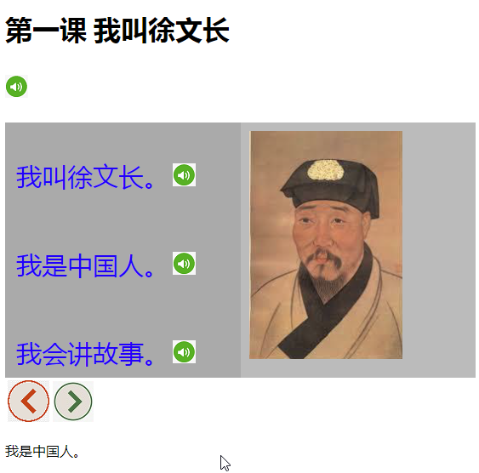Using the <div> tags can help laying out elements on a web page. Follow the example on w3schools.com to create two columns (<https://www.w3schools.com/howto/howto_css_two_columns.asp>); each with different CSS styles for background color, etc.

1. Change the layout as shown to the right.
2. Add two control buttons for navigating from one page to the next, and so on. Additional text and picture files are provided.
3. Test to make the buttons to work. You can assume the user won’t press the prev button if the first page is in display.
4. Try to add a popup window for language learning purposes (such as showing pinyin or English expressions for a Chinese character). You may search for sample code online. One is available again on w3school.com, as follows: <https://www.w3schools.com/howto/howto_js_popup.asp>.

We will learn how to use standard data organization mechanism (like JSON) and other JavaScript APIs (like Google Chart) in Workshop 8.